**3. Pre-requisite Checks**

--- **Reference** - <https://github.com/stacksimplify/aws-eks-kubernetes-masterclass/tree/master/11-DevOps-with-AWS-Developer-Tools>

--- **note** – we are going to perform a pre-requisite check.

**Pre-requisite check**

--- We are going to deploy a application which will also have a ALB Ingress Service and also will register its DNS name in Route53 using External DNS

--- Which means we should have both related pods running in our cluster.

**# Verify alb-ingress-controller pod running in namespace kube-system**

--- **kubectl get pods -n kube-system**

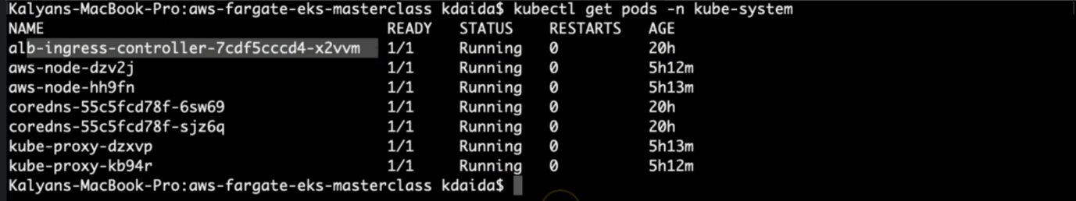

--- **note** – alb-ingress-controller is running.

**# Verify external-dns pod running in default namespace**

--- **kubectl get pods**



**Create ECR Repository for our Application Docker Images**

--- Go to Services -> Elastic Container Registry -> Create Repository

--- Name: eks-devops-nginx

--- Tag Immutability: Enable

--- Scan On Push: Enable

--- Click on Create Repository

--- Make a note of Repository name

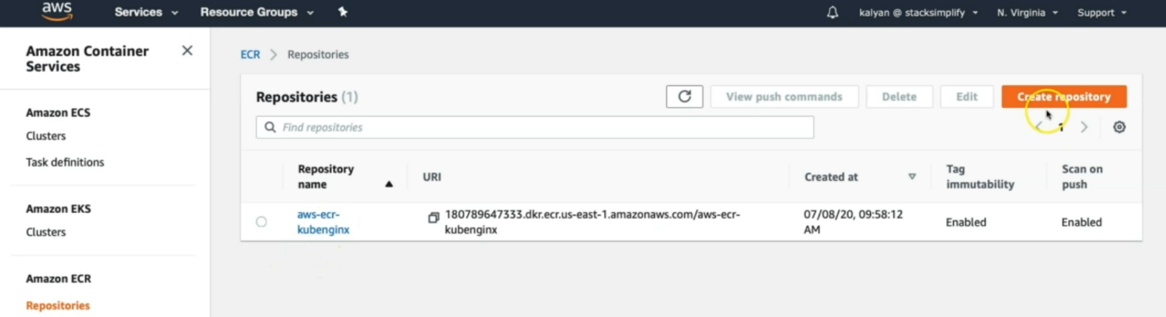

--- click on create repository.

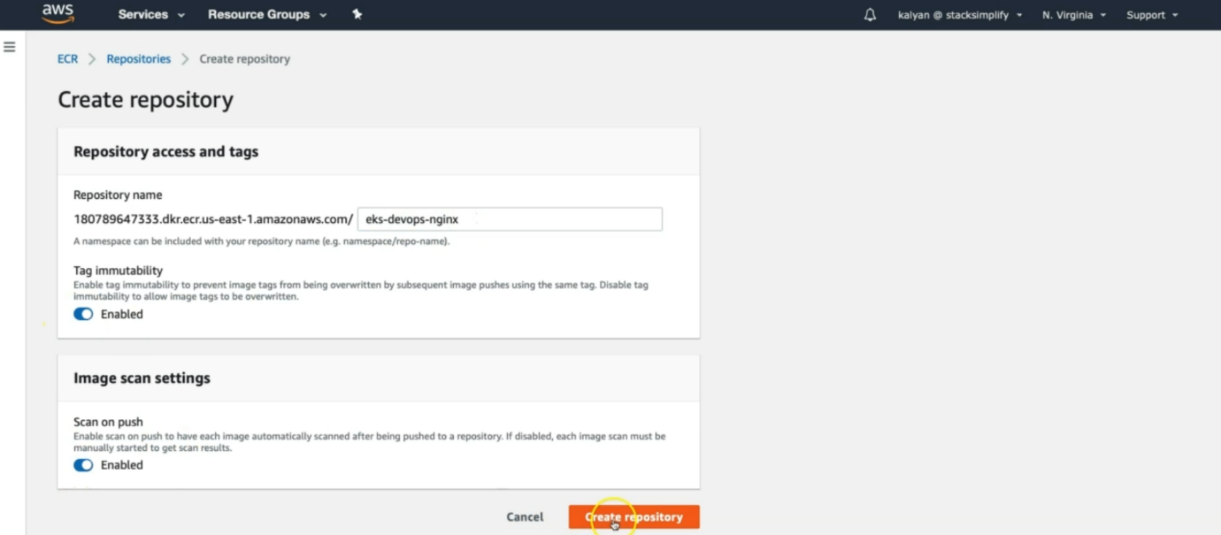

--- click on create repository.

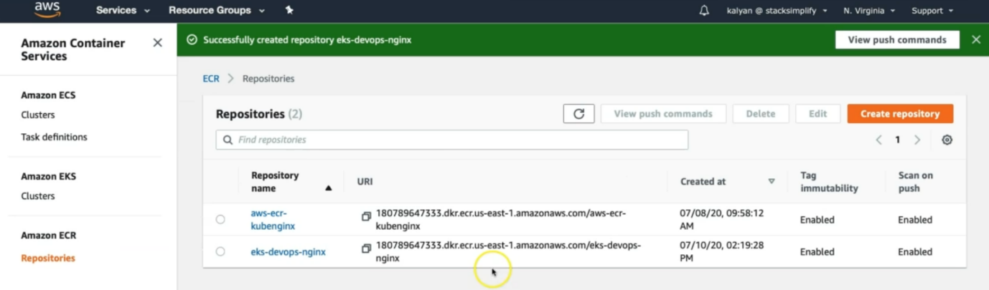

--- this completes the creation of AWC ECR repository.

# Sample ECR Repository URI

180789647333.dkr.ecr.us-east-1.amazonaws.com/eks-devops-nginx